Year 9, Chapter 4.4: Lenses and the Eye

What is a lens?
___________________________________________________________________________
___________________________________________________________________________

A convex lens _____________ outwards. These lenses cause the light rays to _________ together, or converge. If a convex lens is held close to an object, it can be used as a ___________________________ glass. It produces an upright and _____________________ virtual image.

Comparison of convex lenses
Weak flattened lens
Strong curved lens

Describe the following terms:
Focal length: (label on above diagrams)
__________________________________________________________________________________
__________________________________________________________________________________
Real image:
___________________________________________________________________________
___________________________________________________________________________

Draw a ray diagram (see instructions on page 135, fig 4.4.5), for when a real inverted image is produced.

A concave lens curves _______________________. These lenses cause light rays to _____________________ or spread out. They spread lights rays as though they have come from a point __________________ the lens. A concave lens produces images that are ___________________, _________________ and virtual.

Draw a labelled diagram of a concave lens

The Eye
Light enters the eye and is refracted by the ____________________, and focused by the lens, which is ______________. Incoming light is actually focused to form a clear, upside-down image on the ______________, at the back of the eye. This image is converted into a series of electrical signals, which then travel along the _________________ _______________ to the brain. The brain then interprets this information as an image.

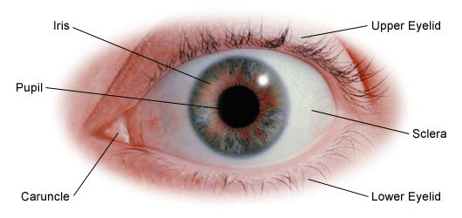
Diagram of the Eye

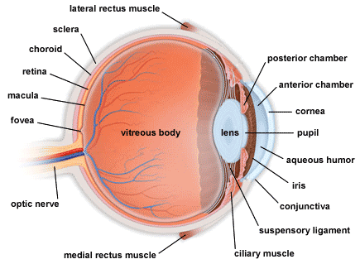

Task: Describe the role of each of the structures of the eye
(Use you textbooks, pg 137, to add any unlabelled structures to the diagrams above)
Aqueous humour
___________________________________________________________________________
___________________________________________________________________________
Cornea
___________________________________________________________________________
___________________________________________________________________________
Lens
___________________________________________________________________________
___________________________________________________________________________
Ciliary muscle/body
___________________________________________________________________________
___________________________________________________________________________

Conjunctiva
___________________________________________________________________________
___________________________________________________________________________
Choroid
___________________________________________________________________________
___________________________________________________________________________
Sclera
___________________________________________________________________________
___________________________________________________________________________
Fovea (centralis)
___________________________________________________________________________
___________________________________________________________________________
Optic nerve
___________________________________________________________________________
___________________________________________________________________________
Eye muscles
___________________________________________________________________________
___________________________________________________________________________
Vitreous humour
___________________________________________________________________________
___________________________________________________________________________
Iris
___________________________________________________________________________
___________________________________________________________________________
Pupil
___________________________________________________________________________
___________________________________________________________________________
Sphincter muscle
___________________________________________________________________________
___________________________________________________________________________
Dilator muscle
___________________________________________________________________________
___________________________________________________________________________

Rods and Cones
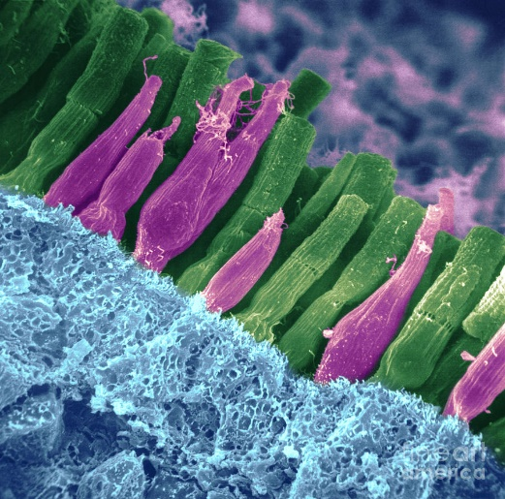
Cone cells are more concentrated (packed) in the ______________ and are receptive to ____________.

Rod cells are located around the _______________ and are nerve cells sensitive to ______ light.

_______________
_______________

Vision problems (pg 138)
The lenses in your eyes focus on objects at different distances by changing focal length (remember focal length = distance from lens to focus).
Describe the action of the muscles attached to lens when a person is looking at an object:
that is far/distant
___________________________________________________________________________
___________________________________________________________________________
that is close by
___________________________________________________________________________
___________________________________________________________________________

What is ‘accommodation’?
___________________________________________________________________________
Why does accommodation get harder as we age?
___________________________________________________________________________
___________________________________________________________________________
What is myopia?
___________________________________________________________________________
___________________________________________________________________________
With reference to lens type, how can myopia be corrected?
___________________________________________________________________________
___________________________________________________________________________

What is hyperopia?
___________________________________________________________________________
___________________________________________________________________________
With reference to lens type, how can hyperopia be corrected?
___________________________________________________________________________
___________________________________________________________________________

Application!!!! The Bionic Eye!
Using page 139, briefly bullet point key ideas as to how the bionic eye aids with impaired vision.

